

Asbestos Register

Casey Station

File [RM8] Ref:  CD14/44 [v5] | Responsible Officer:  Infrastructure Engineer | Authorising Officer:  General Manager Support and Operations | Authorisation Date:  1/10/2018
Version Number: 5 |  |  | Reviewed Date:  16/06/2021
Location of Hard Copies/Points of Use: Antarctic Infrastructure Kingston, Casey Station

Contents
1. Asbestos at Casey 1
2. What is the asbestos register? 1
3. Asbestos Management Plan 1
4. Limitations of the asbestos register 1
5. Disturbing or changing buildings 1
6. What to do before commencing work which may involve asbestos 1
7. Sample information 2
8. Risk assessment criteria 2
9. Asbestos free buildings and structures 3
10. Buildings and structures where asbestos has not been identified 5
11. Buildings and structures which contain asbestos 5
12. Inspection record 6
13. Further information 6
14. Asbestos register table 7

Asbestos at Casey
Asbestos was used as a building product at Casey and Wilkes from 1959 through to the late 1980s. It is still present in a number of the current station buildings and field huts at both Casey and Wilkes and in the old tip site at Wilkes. Australia has now banned the use of asbestos but existing asbestos must be managed to ensure that it does not become a health risk. The AAD’s Antarctic Infrastructure section is responsible for managing asbestos in Antarctica and at Macquarie Island. The station trades team, supported by head office, carries out maintenance and management activities to safely manage the asbestos at Casey.

Materials which can contain asbestos include cement sheet floors and walls or roof cladding, gaskets, and vinyl tiles. Heritage items, for example old electronic equipment may also contain asbestos.

What is the asbestos register?
This asbestos register is a list of all of the known asbestos containing material or material which is presumed to contain asbestos at the station and in the station operating area. This includes station buildings and infrastructure, field huts, heritage sites and abandoned tip sites. The register contains information about the location and condition of asbestos containing material. The register is used to help people at the station work safely around asbestos and is also used to help ensure that asbestos is safely managed and maintained.

Asbestos Management Plan
The Asbestos Management Plan is a comprehensive source of information which defines the AAD’s methods and practices for safely managing asbestos in Antarctica and the subantarctic. Any work which involves asbestos must follow the requirements and procedures contained in the Asbestos Management Plan.

Limitations of the asbestos register
The asbestos register lists known and presumed asbestos containing material. The station has been inspected to identify asbestos, however it is possible that there is asbestos which does not appear in the register. The absence of an entry in the register is not a guarantee that a building or area is free from asbestos.

Disturbing or changing buildings
Precautions need to be taken when doing any work on a building. Work on buildings may only be carried out by authorised personnel. Details of precautions and authorisations are covered in the AAD standard operating procedure Changing or Disturbing the Fabric of a Building.

What to do before commencing work which may involve asbestos
All work which involves asbestos must be carried out in accordance with the procedures outlined in the Asbestos Management Plan. You should read the relevant sections of the plan and ensure that you assess the risks and comply with the requirements.

Sample information
This asbestos register has been prepared based upon inspections and upon analysis of asbestos samples. Information on samples and results is kept by the Antarctic Infrastructure section and is available on request to the Infrastructure Engineer at Kingston. Samples which test negative for asbestos are useful in determining whether asbestos precautions are required when working on a building. These sample results are not presented in this register however they are available on request to the Antarctic Infrastructure section.

Risk assessment criteria
The following criteria are used to rate asbestos risk in this register.

Condition Assessment

- Good – Asbestos or asbestos containing material in a stable matrix, sealed or firmly bonded to substrate. Undamaged. The material is not considered vulnerable to damage, degradation, or uncontrolled fibre release.
- Fair – Asbestos or asbestos containing material shows evidence of exposure, damage or deterioration to small areas. Further damage not likely. Inadvertent exposure to asbestos fibres is possible but unlikely. More frequent monitoring of the condition of these materials is recommended.
- Poor – Asbestos or asbestos containing materials that is exposed, damaged or deteriorating. Although fibre exposure may not be occurring, remedial action is recommended to prevent inadvertent exposure or uncontrolled fibre release.
- Unknown – Asbestos or asbestos containing materials are suspected to be present however the area is inaccessible or the material cannot be sampled without unacceptable damage e.g. interior or fire door.

Friability

- Bonded – Bonded asbestos material is any asbestos containing material other than friable asbestos material.
- Friable – Any material that contains asbestos and is in a form of a powder or can be crumbed, pulverised or reduced to powder by hand pressure when dry.
- Damaged - The material or its covering has become damaged, deteriorated or delaminated due to factors such as changes in building use, changes in operation and maintenance practices, changes in occupancy, or recurrent damage.
- Weathered – Continued exposure to weather and to acid rain results in particles and fibres being dispersed into air and water.

Disturbance Potential

- Low – Material is in good condition, non-friable and well-encapsulated e.g. painted soffit, wall/ceiling lining. Minimal likelihood of damage or disturbance to occur under normal conditions. Potential for fibre exposure and/or transfer of fibres to other areas is unlikely unless the material is damaged or disturbed during maintenance, refurbishment, renovation or demolition.
- Medium – Material is non-friable and in fair condition. Material is in an exposed location having potential for disturbance. No evidence or <10% area damage. There is potential for further damage or disturbance to occur under normal conditions, or potential for fibre exposure and/or transfer of fibres to other areas.
- High – Material is in poor condition or friable. Likelihood exists of further damage or disturbance to materials under normal conditions. Fibre exposure and/or transfer of fibres to other areas is likely.

Risk Rating

- Risk Rating 1 – High, immediate rectification required.
Asbestos materials are damaged or subject to continual disturbance and are unstable. There is an increased potential for fibre exposure and/or transfer of fibres to other areas. Prompt abatement required.
- Risk Rating 2 – Medium risk potential.
Asbestos is unstable and there is a potential for disturbance, or material is accessible and when disturbed may present a short-term exposure risk, or disturbance due to maintenance, refurbishment, renovation, demolition is likely to occur, or disturbance of asbestos cement debris at soil surface in accessible areas is likely to occur. Control measures to be taken at earliest possible time.
- Risk Rating 3 – Low risk, potential hazard during refurbishment.
Friable asbestos is stable and has low disturbance potential, or non-friable asbestos with no or <10% area damage and no exposure risk unless disturbed, or loose cement debris in low access area. Defer action unless disturbance is possible due to maintenance, refurbishment, renovation or demolition.
- Risk Rating 4 – Negligible risk.
Non-friable asbestos material is stable. Low potential for disturbance and does not present a risk unless cut, drilled, sanded or abraded. Defer action unless disturbance due to maintenance, refurbishment or demolition.

Asbestos free buildings and structures
These buildings are asbestos free. They have been constructed entirely from asbestos free materials.

Building or Structure | Maximo Number
Anaresat Radome | L1030
Aviation Hut Office/Workshop | L1863
Aviation Hut Storage Container | L1864
Boat Shed | L1033
Casey Utility Building (CUB) | L3411
Concrete Batching Plant | L1067
Container (Air Transport) | L1502
Container (Electrical Store) | L1041
Container (Load Bank) | L1384
Container (Metal Storage) | L1044
Container (Meteorology Store) | L1077
Container (Plumbing Store) | L1046
Container (Recycling) | L1053
Container (Thala Valley Waste Treatment No. 1) | L1503
Container (Thala Valley Waste Treatment No. 2) | L1504
Container (Timber Store) | L1049
Detonator Magazine | L1588
East Wing | L2442
Emergency Food Container | L3387
Emergency Helipad | L1065
EPH Fuel Settling Tank (2015) | L3408
Explosives Magazine | L1587
Field Equipment Store | L1035
Gas Storage Platform | L1036
Hazardous Goods Store | L1045
Hobby Hut | L1950
Main Helipads | L1935
Meteorology Enclosure | L1075
Meteorology Satellite Dome | L1076
Meteorology Theodolite Hut | L1073
Mitchell Peninsula Emergency Shelter (Kenny) | L1321
Old Seismic Hut (Removed from Station in 2019) | -
Peterson Island Emergency Shelter | L1322
Quarry | L1759
Receiver Antenna Farm | L1028
Ring Main Unit No. 1 | L1015
Ring Main Unit No. 2 | L1016
Ring Main Unit No. 3 | L1017
Ring Main Unit No. 4 | L1018
Seismic Hut | L1079
Ski Way | L1637
Skiway Office/Workshop/Accommodation | L1862
Transmitter Antenna Farm | L1026
Vehicle Refuelling Point | L1066
Waste Treatment Building | L1058
West Wing | L3389
Wharf | L1062
Wilkins Runway | L1636
Wilkins Runway Accommodation | L1690
Wilkins Runway Amenities | L1694
Wilkins Runway Garage | L1861
Wilkins Runway Living Quarters | L1692
Wilkins Runway Operations Building | L1859
Wilkins Runway Power Generation | L1691
Wilkins Runway Storage Complex | L1860
Wilkins Runway Workshop | L1693
Workshop Fire Water Container | L1043

Buildings and structures where asbestos has not been identified
The following buildings and structures have been inspected and no asbestos has been found. They are not listed as asbestos free buildings because there is a possibility that they may contain asbestos which has not been discovered. Many of these buildings are old and there may be uncertainty around the types of materials which were used in their construction. All work which may disturb the fabric of these buildings must still consider the risk of asbestos.

Building or Structure | Maximo Number
Browning Peninsula Hut | L1327
Container (Aquarium) | L1082
Container (Biology Lab) | L1047
Container (Wet Lab) | L1054
Digisonde | L1084
Edgeworth David Base Huts | L1315
Emergency Powerhouse | L1013
Emergency Vehicle Shelter | L1059
General Workshop | L1031
Green Store | L1034
Hydroponics | L1051
Incinerator Building, including incinerator door seals | L1057
Magnetic Absolute Hut | L1080
Old Carpenter's Workshop (cladding removed in 2019 structure removed Jan 2023) | L1032
Science Building | L1078
Seismic Vault | L1505
Site Services | L1061
Smokers Hut | L1052
Tankhouse | L1056
Wharf Hut | L1055
Wharf Storage Rack | L1501
Wilkes Radome Building | -

Buildings and structures which contain asbestos
The following buildings and structures contain or are presumed to contain asbestos. This table is intended as a summary. Details are given in the asbestos register table.

Building or Structure | Maximo Number
Anaresat Equipment Building | L1029
Balloon Release Building | L1074
Incinerator Fuel Tank (should be removed if replaced from warren to neil) | L1072
Incinerator Fuel Tank | L1072
Jack's Donga | L1317
Lower Fuel Farm | L1507
Mabel Hut | L1508
Main Powerhouse | L1012
MPH Fuel Settling Tank | L1506
Operations Building | L1024
Receiver Building | L1027
Red Shed | L1020
Robinson's Ridge Hut | L1323
Transmitter Building | L1025
Upper Fuel Farm | L1934
Vehicle Fuel Settling Tank | L1070
Wilkes Balloon Hut | -
Wilkes Geomagnetic Hut | -
Wilkes Heater Shelter | -
Wilkes Hilton Hut | L1328
Wilkes Old Tip Site | -
Wilkes Riometer Building | -

Inspection record
The following asbestos inspections have been carried out.

Inspection Details (Maximo work order number) | Person | Date
Initial inspection, sampling and  preparation of asbestos register. | J. Lea, R. Thomas and D. Smith | February 2005
Condition inspection. | C. Munro | August 2008
Condition inspection. | D. Brett | June 2009
Condition inspection. | P. Trezise | August 2011
Condition inspection (WC252909). | T. Kerr | April 2015
Condition inspection (WC258093). | A. Cook and D. Pangrazio | January 2016
Condition inspection (WC265188). | C. George | February 2017
Condition inspection (WC273912). | C. Fitzgerald, K. Ellis and B. Sambrooks | January 2018  September 2018
Condition Inspection (WC298154). | R. Jackson | February 2020
Condition Inspection (WC 307397). | T. Egan | February 2021
Condition Inspection (WC327107). | Ray Chivas | March 2023
Condition Inspection (WC340258). | J.Knottenbeld | March 2024
Condition Inspection ( ). |  | 2025
Condition Inspection ( ) | xxxx | 2026

Further information
If you have questions about asbestos or you are unsure how to interpret the information in this register, please contact you station Engineering Services Supervisor, Building Trade Supervisor, Work Health and Safety Team or the Director Infrastructure Maintenance and Operations at Kingston.

- Building Trade Supervisor - Cameron Lea (03) 6218 2277
- Director Infrastructure Maintenance and Operations – Lisa Wilkinson (03) 6232 3335
- WHS Team – whs@aad.gov.au

Asbestos register table
Location & Maximo Number | Item | Sample Number | Date Identified | Condition | Friability | Disturbance Potential | Risk Rating | Comments | Action Required | Inspection Notes
Anaresat Equipment Building  L1029 | Cold porch lining. | Not sampled | JAN 2024 | Good | Bonded | Low | 4 | Assume positive.  23 - Very good condition  24 - “as above “ | Check label and re-inspect annually.
Balloon Release Building  L1074 | Dado wall throughout up to 2.1m from the floor. | M031/10  Casey 5 | JAN 2023 | Fair | Bonded | Low | 4 | Assume Positive  24 - Overall good condition. painting required in plant room to re-seal | Check label and re-inspect annually. | 23 - All wall surfaces in good condition.  24 - Minor paint re-seal action required
Anaresat Equipment Building  L1029 | Cold porch lining. | Not sampled | 01/06/2009 | Good | Bonded | Low | 4 | Assume positive. | Check label and re-inspect annually. | Good condition
Balloon Release Building  L1074 | Dado wall throughout up to 2.1m from the floor. | M031/10  Casey 5 | 09/03/2010 | Good | Bonded | Low | 4 | Assume Positive | Check label and re-inspect annually. | Small holes through entire building. These were all sealed up.
Incinerator Fuel Tank  L1072 | Gaskets in tank access hatch covers. | Not sampled | 28/9/2018 | Good | Bonded | Low | 4 | Gaskets may contain asbestos. Take precautions when handling gaskets. | Inspect when hatch lids are removed. | Annual inspection is not required.
Jack’s Donga L1317 | Insulation. | Not sampled | 01/12/2004 | Good | Enclosed | Low | 4 | Assume positive. Insulation is entirely contained by structure. | Check label and re-inspect annually. | Couple of small holes, this will need to be sealed over.
Lower Fuel Farm  L1507 | Gaskets in tank access hatch covers. | Not sampled | 28/9/2018 | Good | Bonded | Low | 4 | Gaskets may contain asbestos. Take precautions when handling gaskets. | Inspect when hatch lids are removed. | Annual inspection is Not required.  23 - Not inspected  24 - Not inspected
Mabel Hut  L1508 | Original floor sheet and vinyl tiles. | Not sampled | DEC 2024 | Good | Bonded | Low | 4 | New (non-asbestos) floor sheet now covers old floor. | Check label and re-inspect annually.  23 - Underside of floor in good condition.  24 - “As above” | 23 - Asbestos cement floor has been sheeted over with Villaboard. Presumed non-asbestos.
Main Powerhouse  L1012 | West wall in control room up to 1.8m Dado line. Engine room up to 1.8m Dado line . | M031/10 | Jan 2024 | Fair | Bonded | Low | 4 | All wall sheets in control room asbestos free except West wall. Engine room asbestos free above Dado line.  24 - Northern wall requires re-seal.  Engine room below dado needs spot paint where screws are exposed. | Check label and re-inspect annually.  23 - Northern wall.  Suggest repainting up to Dado line.  Low priority.  24 - West side of door northern end repainted + spot painted perimeter. 17/01/24 | 23 - Walls in fair condition.  24 - General wear and tear from sinks results in a breakdown of paint seal.  See work order for works carried out.  CW271635
MPH Fuel Settling Tank  L1506 | Gaskets in tank access hatch covers. | Not sampled | May 2023 | Good | Bonded | Low | 4 | Gaskets may contain asbestos. Take precautions when handling gaskets. | Inspect when hatch lids are removed. | Annual inspection is not required.  23 - Not inspected.  24 - Not inspected
Main Powerhouse  L1012 |  | M020/09  M031/10 | Jan 2024 | Fair | Bonded | Low | 4 | Assume all floor sheets contain asbestos. | Check label and re-inspect annually.  24 - Check label and re-inspect annually. | 24 - Floor sheets have old penetrations. Previously glue spray sealed and again glue spray sealed. No action required
Surrounding area adjacent to Old Carpenter’s Workshop L1032 | Debris  Old Carpenter’s Workshop removed Jan 2023, now ITC comms site. |  | Jan 2024 | Fair | Weathered | Low | 3 | 24 - Debris not seen through soil and surrounding area of Old Carpenter’s Workshop. | Continue annual inspection and remove ACM debris when identified.
Operations Building  L1024 | Floor sheets. | 301038 | March 2024 | Fair | Bonded | Low | 4 | Note that there are some asbestos free sheets in the foyer area.  24 - Inspection showed no disturbed floor sheet areas although I suspect that there is a high amount of residual dust from initial construction.  Samples collected. Asbestos test should be done. Full PPE should be always worn. | Check label and re-inspect annually.  24 - SOP for entry/exit Is suggest or due diligence with any task required in sub floor area.  Sample results to determine level of risk mitigation. | 23 - Wall in fair condition  No action nessesary.
Operations Building  L1024 | Subfloor area. | M020/09 | March 2024 | Fair | Bonded | Low | 4 | Subfloor has history of asbestos sheet disturbance. Precautionary measures (full PPE) must be taken for access.  24 -“As above” | Check label and re-inspect annually.  24 -SOP to be developed | 23 -Sub floor in fair condition. PPE required to enter space.
Receiver Building  L1027 | Both sides of internal partition wall that forms the cold porch. | M031/10  Casey 7  C17-5  C17-6  C18-4 | Feb 2024 | Fair | Bonded | Low | 4 | Painted cement sheet walls to Cold Porch Partition Walls. All other walls painted steel. Note that floor tile sample tested negative.  24 - Lower right (west upon entry) has some flaking paint that requires re-sealing. | Check label and re-inspect annually.  24 - Work order created for re-seal works (CW271401) | 24 - Work order created for re-seal works CW271401
Red Shed L1020 | Crawl way under floor. Warning labels fixed to AC sheets. | Not sampled | March 2024 | Good | Sealed with paint.  Bonded | Low | 4 | Painted cement sheet – assume positive (manufacturer label states asbestos present).  24 -Around 20+ floor sheets crawl boards sealed with red paint | Check label and re-inspect annually. | 23 - All sheeting in good condition. All sheets sealed with paint.  Sheet would have to be cut into pieces to remove from sub floor.
Red Shed – Plantroom | Ferroli boiler - gasket | Not sampled | May 2025 |  |  |  |  | Based on age of materials – assumed to contain asbestos | Maximo work orders for inspections of boiler will be revised to include the potential for asbestos sheeting within the boiler chamber.
Robinson’s Ridge Hut L1323 | Floor sheet and floor tiles.  23 - Only in the foyer. | C17-7  C17-8  C17-9 | Jan 2024 | Good | Bonded | Low | 4 | Floor sample tested positive. Note that cold porch and living area wall samples tested negative.  24 -Asbestos floor sheet panels visually in good condition | Check label and re-inspect annually. | 23 - Carpet tiles have been laid in the living area.
Transmitter Building  L1025 | Both sides of internal partition wall that forms the cold porch. | M107/04 | Jan 2024 | Good | Bonded | Low | 4 | Painted cement sheet walls to Cold Porch partition walls. All other walls painted steel.  24 - Walls and paint seal all in good condition | Check label and re-inspect annually.
Upper Fuel Farm  L1934 | Gaskets in tank access hatch covers. | Not sampled | May 2023 | Good | Bonded | Low | 4 | Gaskets may contain asbestos. Take precautions when handling gaskets. | Inspect when hatch lids are removed. | Annual inspection is not required.  24 - Not Inspected due to un-necessary removal of lid
Vehicle Fuel Settling Tank  L1070 | Gaskets in tank access hatch covers. | Not sampled | May 2023 | Good | Bonded | Low | 4 | Gaskets may contain asbestos. Take precautions when handling gaskets. | Inspect when hatch lids are removed. | Annual inspection is not required.  24 - Not Inspected due to un-necessary removal of lid
Wilkes Balloon Hut | Internal cement sheeting. | M107/04 | Jan 2024 | Poor | Bonded | Medium | 4 | 24 - Building has lost external cladding. AC sheeting has blown in. | Check label and re-inspect annually. | Lots of damage, in poor condition, blizzed in
Wilkes Geomagnetic Hut | Floor tiles. | M107/04 | July 2023 | Fair | Bonded | Low | 4 |  | Check label and re-inspect annually. | Lots of damage, in poor condition, blizzed in
Wilkes Heater Shelter | Internal cement sheeting. | M107/04 | Jan 2024 | Poor | Bonded | Medium | 2 | 23 - As building was built in the 1940s, asbestos cement sheeting assumed. | 23 - Broken pieces of cladding need to be bagged up & RTA. | Lots of damage, in poor condition, blizzed in
Wilkes Hilton Hut  L1328 | External cement sheet cladding over tin. | M107/04 | Jan 2024 | Fair | Bonded | Medium | 4 | 23 & 24 - External AC cladding losing its external coating. | Check label and re-inspect annually. | Some panels are damaged, points around gas need repairing
Wilkes Old Tip Site  Coordinates: WGS1984 UTM Zone 49S  Easting  479630.861  Northing  2651038.069 | Rubbish. Remediation team uncovered rubbish tip which contains small pieces of material which are likely to contain asbestos. | Not sampled | Jan 2024 | Fair-  - | - | -  - | 4  - | 24 - Wilkes Old Tip site was located however no visual on any asbestos. Covered in snow. Disturbance potential low due to snow coverage. Low disturbance potential unless excavation or remediation work being carried out. | Risk assessment required before excavation work or other work at the tip site.  23 - Emu bob for asbestos products needed in the summer melt.  24 - Emu bob not carried out. | Annual inspection is not required.  23 - Found 800mm long piece of pipe near old Air Sampling Building.
Wilkes Riometer Building | Floor tiles. | M107/04 | 24/12/2004 | Fair | Bonded | Low | 4 |  | Check label and re-inspect annually. | 23 - Building could not be located
Old Casey – Ionosonde Vicinity  WGS 84  UTM Zone 49S  2649067.453 MN  479288.229mE | Assumed Asbestos pipe | Not tested  Assumed positive | 06/01/24 | Poor | Friable | High | 2 | 24 - Remediation team identified an assumed exposed asbestos pipe at old Casey / Ionosonde area.  Pipe very weathered and in need of prompt clean up due to potential of exposure in trafficable area within extended station. | 24 - Asbestos plan developed and removal of pipe.  60kgs removed and disposed of at asbestos RTA Bin.  See workorder for further details. No asbestos remains at immediate site. Suggest annual walkaround as part of this annual emu bob initiative and collect any further pieces that may be found. | 24 - Annual inspection on old Casey / Ionosonde area is recommend during summer melt to identify any further ACM.  See attached images 20  See work order for further information.  CW271638
Reeve Hill | ACM Sheet | Not tested  Assumed positive | 23/01/24 | Good | Bonded | Low | 4 | 24 - Annual emu bob identified a3 sized asbestos sheet at base southern base of reeve hill. Piece was collected and disposed of accordingly. | 24 - Suggest annual walkaround as part of this annual initiative and collect any further pieces that may be found.
Hydroponics:

- Sticker on wall lining to say asbestos. As door jamb and now wall is severly rotting away from ground up, 1 x hole was sealed with ply, due to the nature of the damage, suggests that is isn’t asbestos, and it not being on the register? Can we please confirm this.

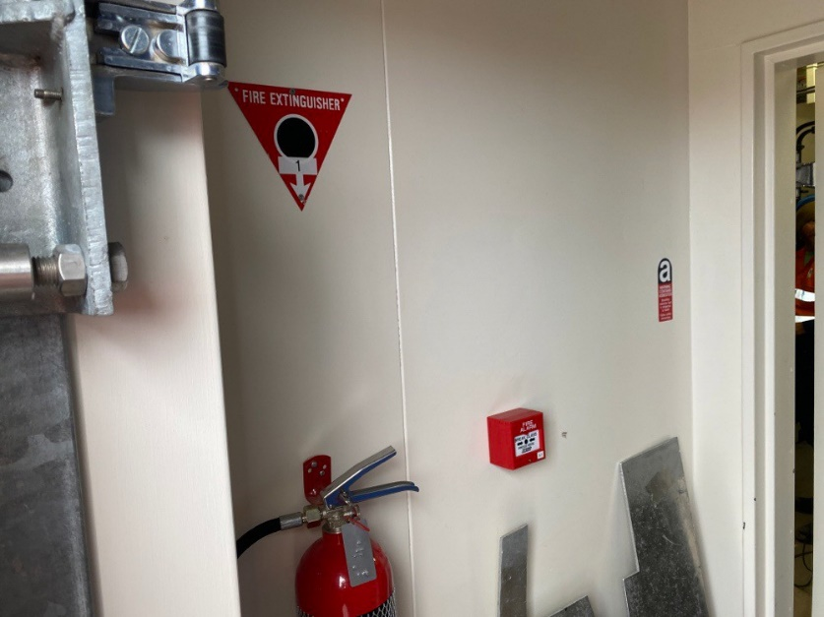 | Image 1: Anaresat Equipment Area L1029  Cold Porch Lining
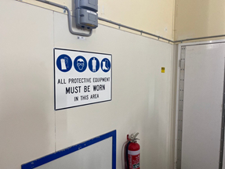 | Image 2: Balloon Release Building L1074 Dado Wall
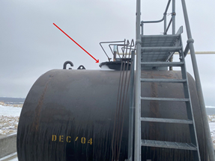 | Image 3: Incinerator Fuel Tank L1074  Gaskets in Tank
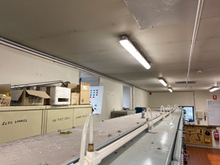 | Image 4: Main Powerhouse L1012  Internal Wall Lining
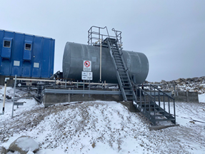 | Image 5: MPH Fuel Tank L1506  Gaskets
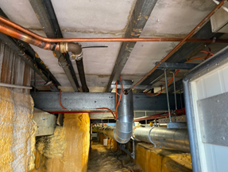 | Image 6: Main Powerhouse L1012  Floor Sheet  Note  23 - Penetrations have broken sheet when pipe work was installed. No loose material visible.  24 - Sprayed PVA GLUE
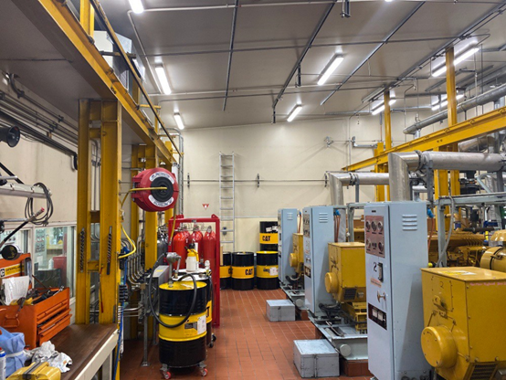 | Image 7: Main Powerhouse Wall Lining
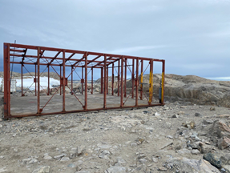  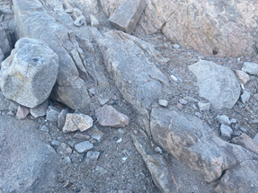 | Image 8: Old Carpenters Workshop L1032  Exterior Cladding Removed  (debris from weathering still possible in this area)  Note - Building frame dismantled & RTA Jan 2023  Now it is the site of the ITC communication containers.  Asbestos material not found on site.
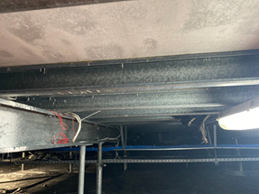 | Image 10: Operations Building L1024  Floor Sheet
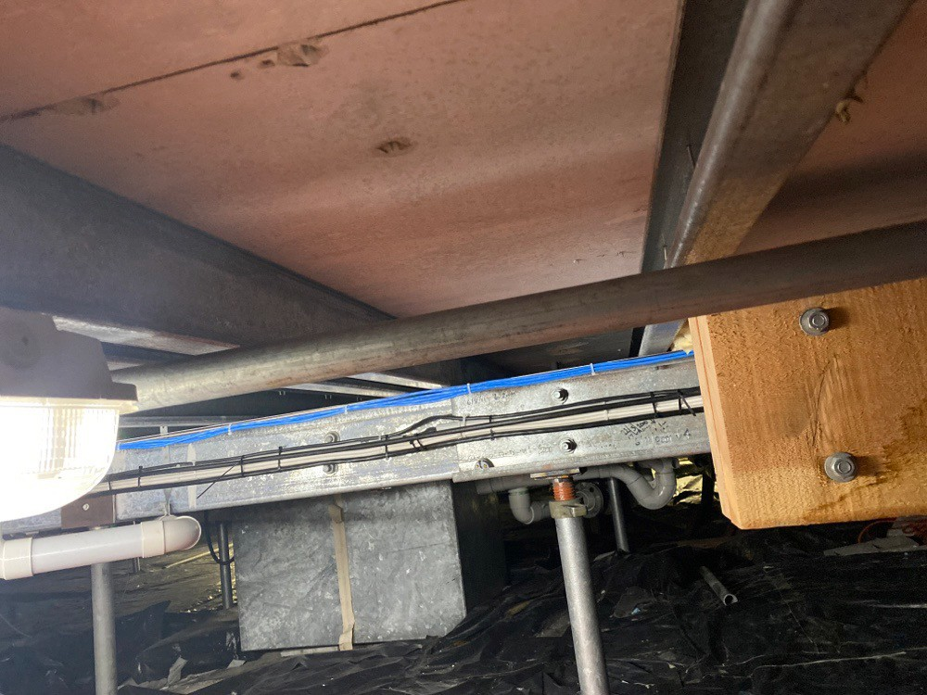 | Image 11: Operations Building L1024  Subfloor Area
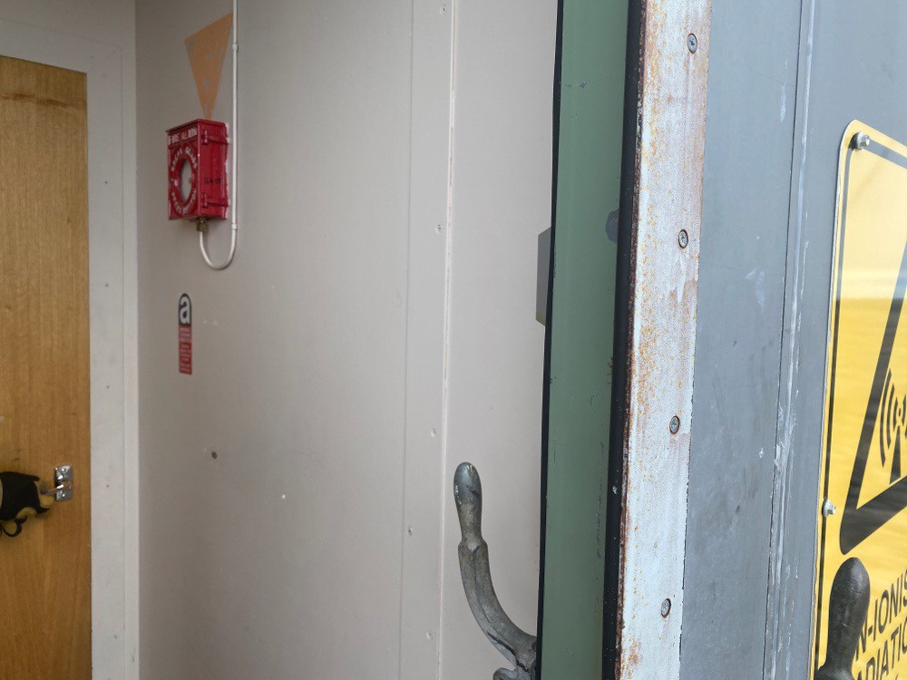 | Image 12: Receiver Building L1027  Internal Cold Porch
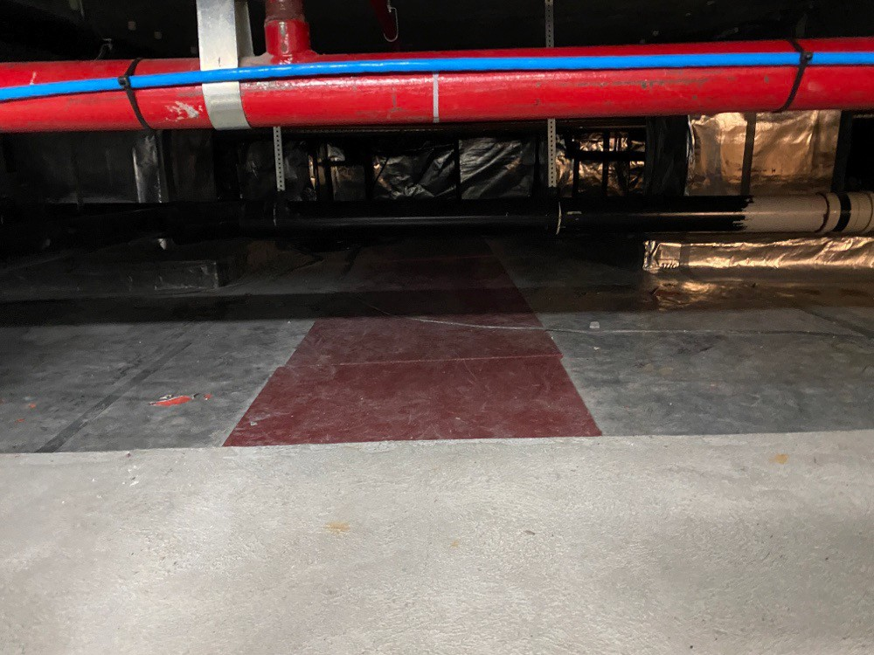 | Image 13: Red Shed L1020  Walkway Under Floor - Cement Sheet
 | Red Shed – Boiler
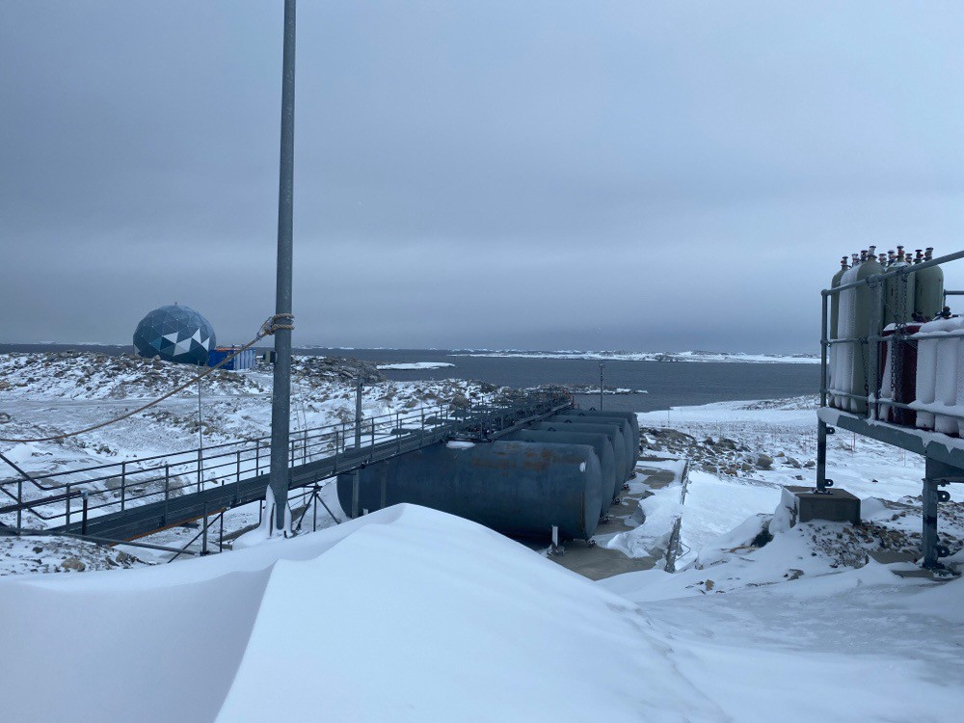 | Image 14: Upper Fuel Farm L1935  Gaskets
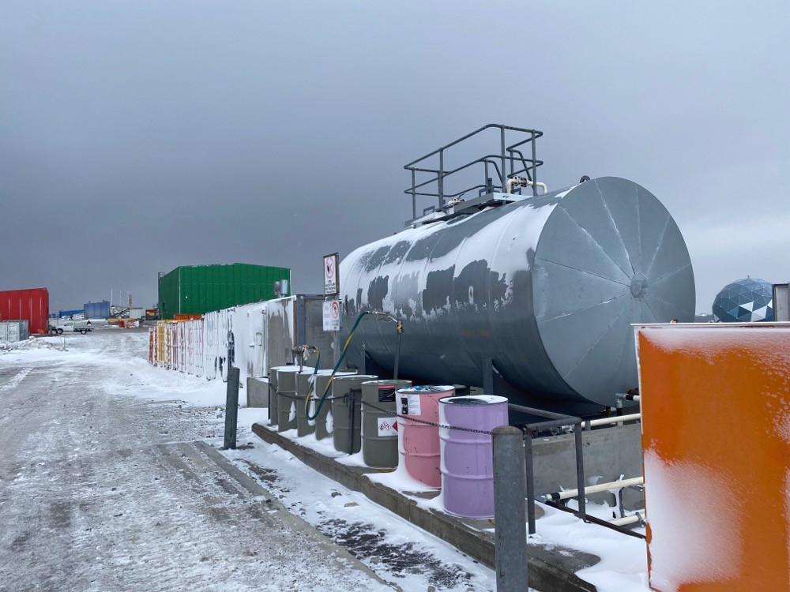  1070 | Image 15: Vehicle Fuel Settling Tank L1070  Gaskets

?? Wilkes Hilton – TBC
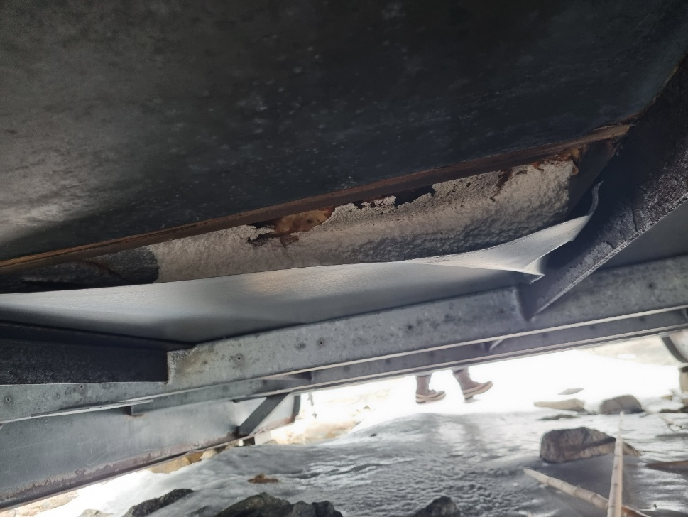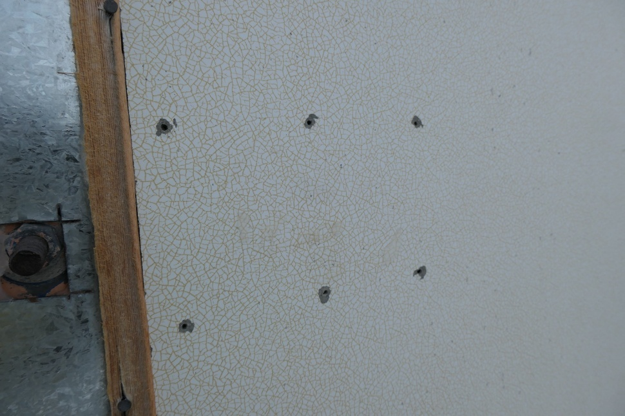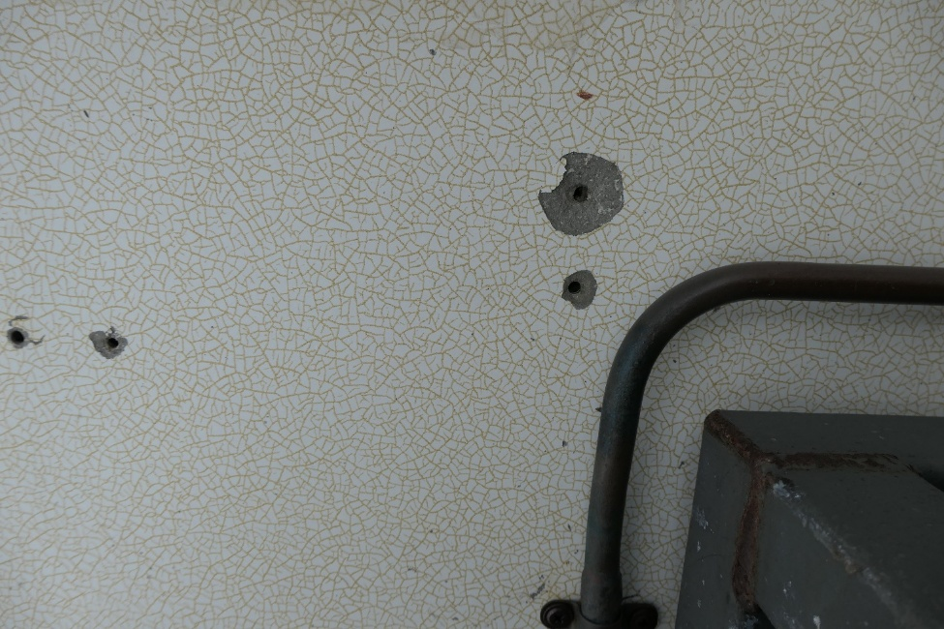

Wilkes Hilton - External cladding 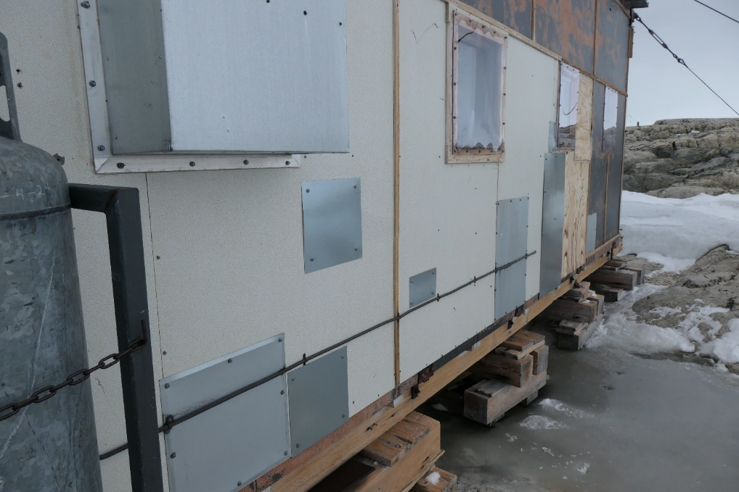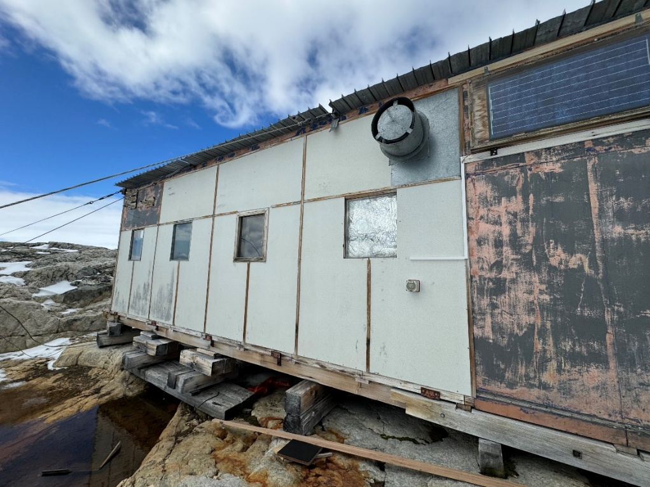

Wilkes Heater Shelter
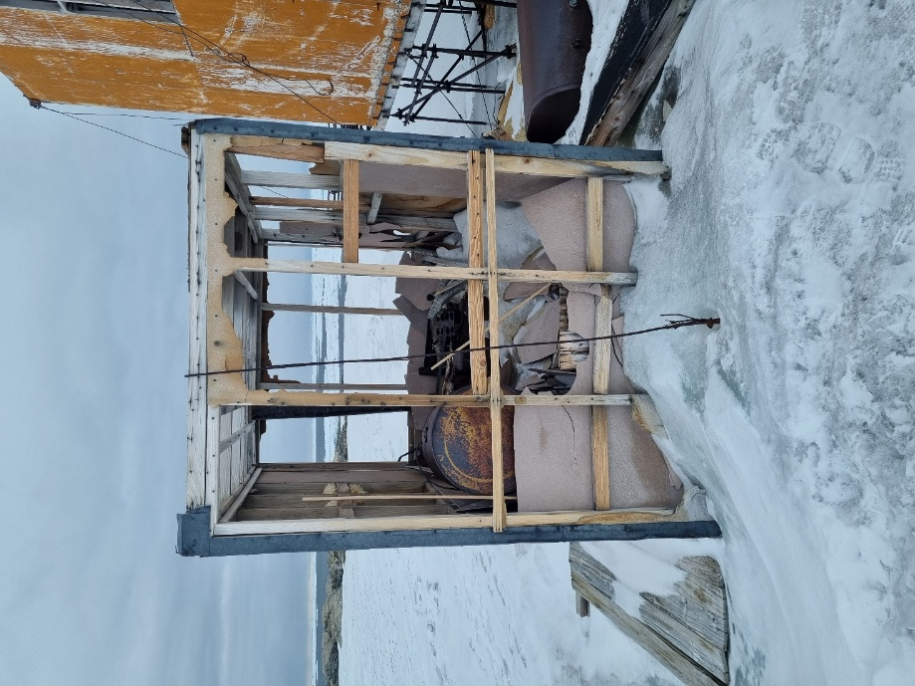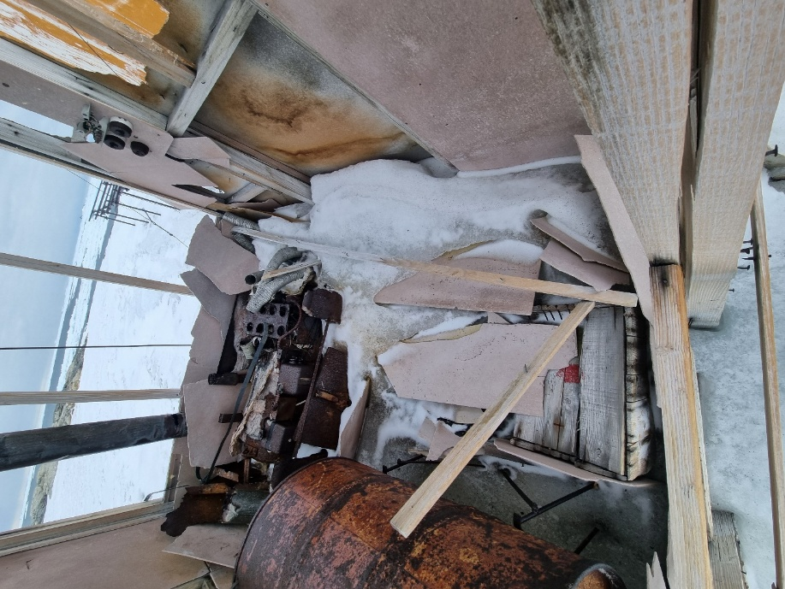

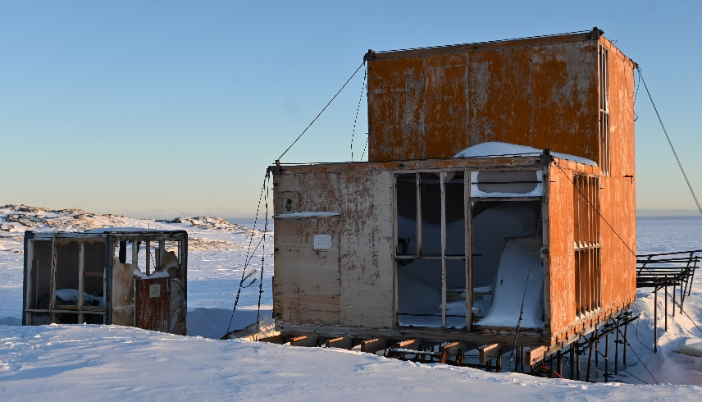
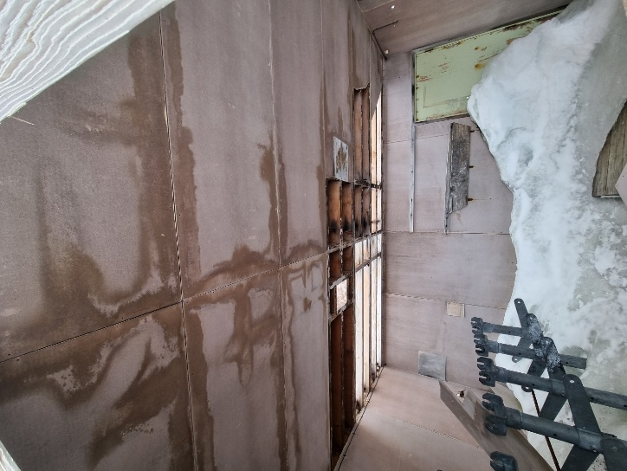

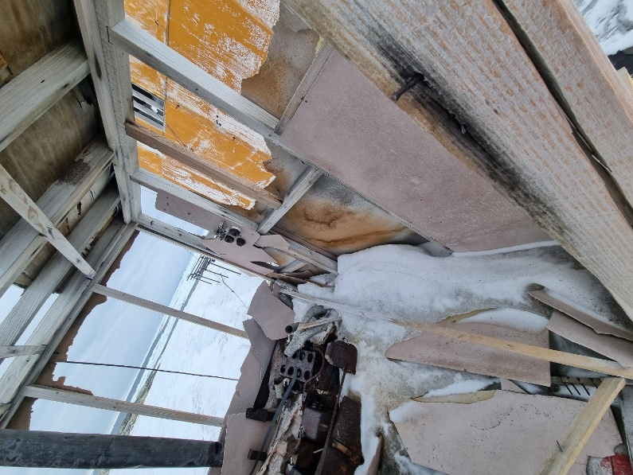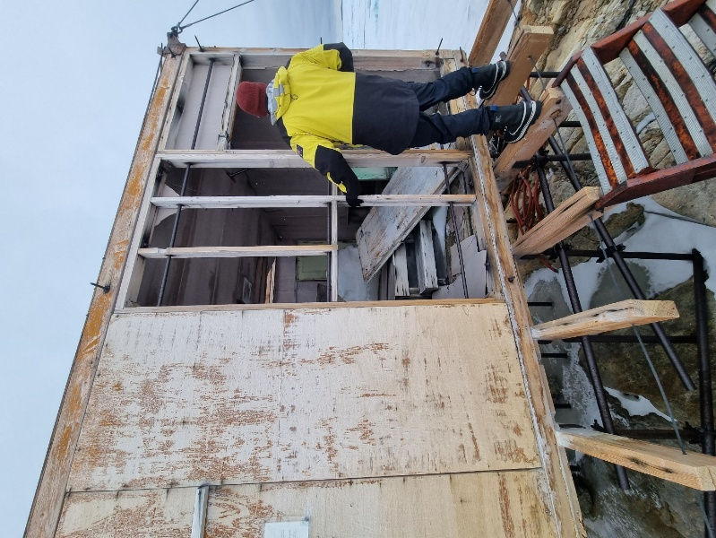
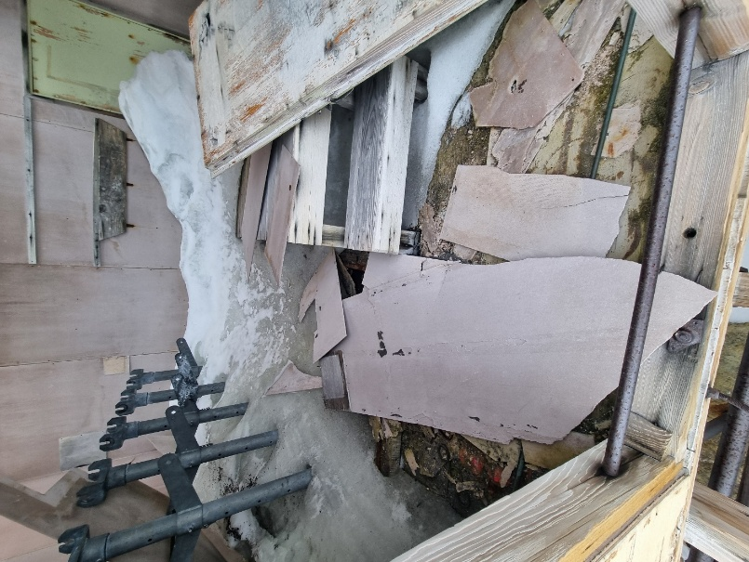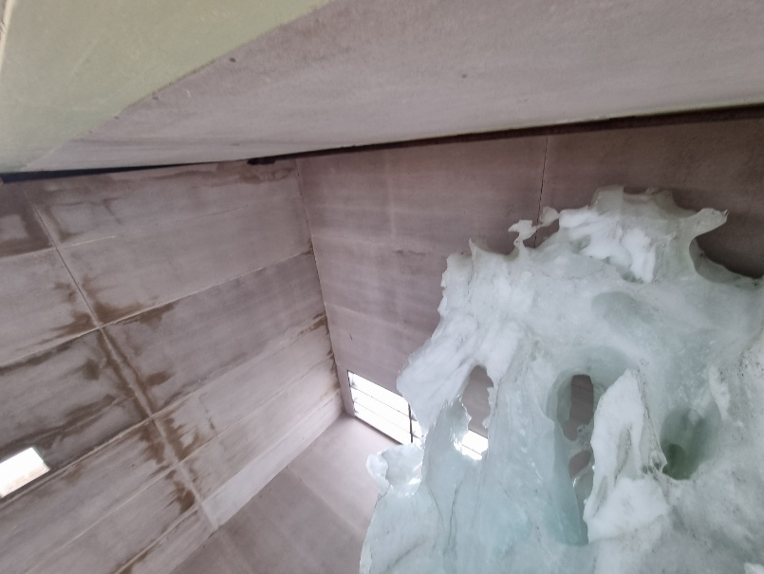

Old Casey – Ionosonde Vicinity Jan 2024




